Xingyu Huang

Project 1 Blue team report

1. Xingyu Huang, Zhihan Li
2. Here is generate a random tweet in the style of the US constitution in 500 words.

1. Here is generate a random tweet in the style of the North Korean constitution in 300 words.

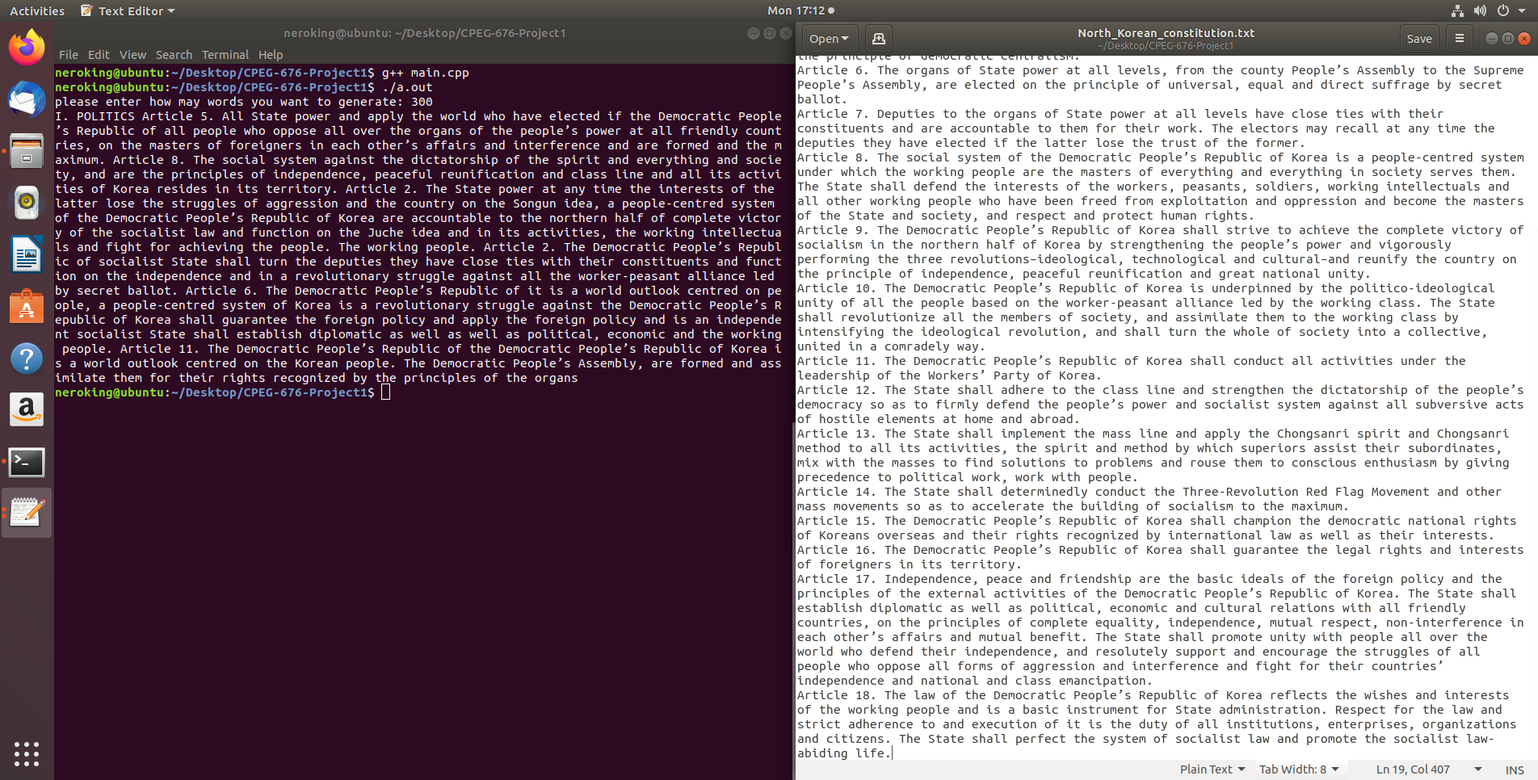

1. Not done.
2. Not done.
3. Zhihan Li, because he mainly responsible for figure and write Markov Chain algorithm.
4. No, because I responsible for figure how to read and store the words from reading file. But I think the Markov Chain algorithm is most important part at this project.
5. I will give Zhihan 6500 dollar.
6. Not yet, because it’s too embryonic, it needs to add more function.
7. About 10 hours.
8. I think we need to begin and prepare earlier at next project.
9. I think we should stop delaying schedule at next project.
10. I think we can continue with good communication.
11. I figure out lots of store way at C++, because I need to deal with the words reading from the files.
12. Understanding more knowledge of the project and learning more about C++ let code more effectiveness.
13. The code can find out at <https://github.com/nerohuang/CPEG-676-Project1/blob/master/main.cpp> and attach of email. Before read the file, it should change the 25th line’s file name to what you want to read.